2010

1. According to many anthropologists, a land bridge during the Ice Age allowed migration between
which two continents?
(1) South America and North America
(2) North America and Europe
(3) Asia and North America
(4) Europe and Asia

***********************************************************************************

“Transportation Costs Rise as Gasoline Prices Reach Record High”
“Unemployment Rate Drops 1.5% in Upstate New York”
“Threat of Recession Leads to Budget Cuts”

2. Which social scientist would most likely study the information reported in these headlines?
(1) psychologist
(2) economist
(3) archaeologist
(4) geographer

***********************************************************************************

3. Which of these examples is a secondary source of information about industrialization?
(1) diary of a factory worker
(2) photograph of a child working in a factory
(3) letter written by an immigrant textile worker
(4) textbook chapter about Andrew Carnegie

4. What was one impact of European exploration on Native American Indians?
(1) European farming techniques were quickly adopted.
(2) Many Native American Indians were resettled throughout Europe.
(3) Conflicts between Native American Indian tribes ended.
(4) Diseases brought by Europeans caused large numbers of deaths.

5. Which religious group is correctly paired with the colony its members helped establish?
(1) Puritans →Georgia
(2) Quakers →Pennsylvania
(3) Pilgrims →Virginia
(4) Catholics →Rhode Island

6. Who were the first Europeans to establish a colony in what is now New York State?
(1) Spanish
(2) Dutch
(3) English
(4) French

7. Which cash crop is credited with helping the Jamestown colony to survive?
(1) tobacco
(2) rice
(3) cotton
(4) sugar cane

8. The Virginia House of Burgesses was important in the development of colonial America because it
was the first attempt to:
(1) practice representative democracy
(2) start a plantation system of farming
(3) protest against mercantilism
(4) establish religious freedom

***********************************************************************************

“…give me liberty or give me death!”
“A government of our own is our natural right…”
“We must indeed all hang together or, most
assuredly, we shall all hang separately.”

9. During the period of the American Revolution, these statements were made by members of which group?
(1) Redcoats
(2) Patriots
(3) Tories
(4) Native American Indians

***********************************************************************************

Base your answer to question 10 on the map below and on your knowledge of social studies.

Aftermath of the French and Indian War

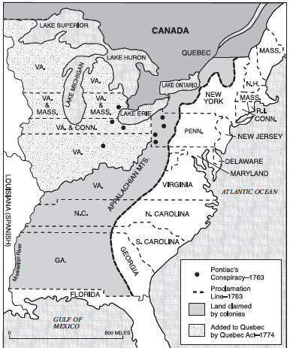

10. Many colonists were angered by the Proclamation of 1763 because it
(1) took too much land from Canada
(2) gave Florida to the French
(3) limited their freedom to move west
(4) encouraged raids by Native American Indians

11. The Battle of Saratoga was significant in the Revolutionary War because it:
(1) ended the British threat to the South
(2) guaranteed Canadian help for the colonists
(3) convinced the French to support the Americans
(4) forced the British to withdraw from North America

12. Which document guarantees freedom of speech, the right to bear arms, and protection from
unreasonable search and seizure?
(1) Bill of Rights
(2) Albany Plan of Union
(3) Declaration of Sentiments
(4) Federalist Papers

***********************************************************************************

“. . . We hold these truths to be self-evident, that
all men are created equal, that they are
endowed by their Creator with certain
unalienable rights, that among these are life,
liberty, and the pursuit of happiness. . . . ”

13. Which document contains these words?
(1) Mayflower Compact
(2) Treaty of Paris
(3) Emancipation Proclamation
(4) Declaration of Independence

***********************************************************************************

14. Which feature of the Constitution prevents one branch of the national government from becoming
too powerful?
(1) federal supremacy
(2) checks and balances
(3) electoral college
(4) elastic clause

15. The purpose of the Lewis and Clark expedition was to explore land gained through the:
(1) Louisiana Purchase
(2) Gadsden Purchase
(3) purchase of Florida
(4) purchase of Alaska

16. One effect of the Supreme Court decision in Marbury v. Madison (1803) was to:
(1) establish the power of the Court to declare a law unconstitutional
(2) allow Congress to tax income
(3) approve the president’s power to veto bills
(4) settle differences between the House and the Senate

17. One result of the War of 1812 was that the United States:
(1) defeated Spain
(2) took control of Cuba
(3) gained land from Canada
(4) maintained its independence from Great Britain

***********************************************************************************

Base your answer to question 18 on the statement below and on your knowledge of social studies.

“We must create a tax on goods entering our
country to protect products made here in America.
Our government must help support businesses
when they are new and weak if we want them to
grow in time.”

18. In the early 1800s, who would most likely make this statement?
(1) New England minister
(2) Northern factory owner
(3) Southern sharecropper
(4) Western gold miner

***********************************************************************************

19. Which project, completed in 1825, resulted from Governor DeWitt Clinton’s plan to link the
Hudson River to the Midwest?
(1) National Road
(2) Champlain Canal
(3) Erie Canal
(4) Hoover Dam

Base your answer to question 20 on the graphic organizer below and on your
knowledge of social studies.
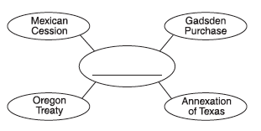

20. Which title best completes this graphic organizer?
(1) Expansion of Slavery
(2) Results of Manifest Destiny
(3) Goals of the Monroe Doctrine
(4) Adoption of the Missouri Compromise

***********************************************************************************

Base your answer to question 21 on the cartoon below and on your knowledge of social studies.

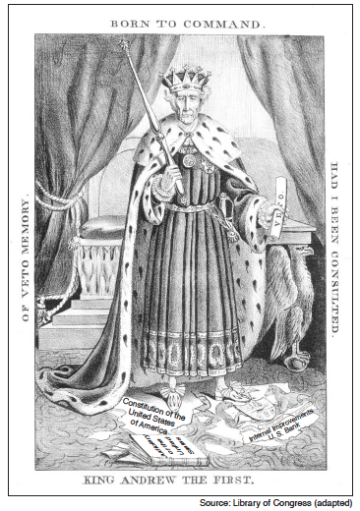

21. This portrayal of President Andrew Jackson reflects the opinion of some of his opponents that the:
(1) executive branch had become too powerful
(2) British had too much influence over the president
(3) president had become too sympathetic to the common man
(4) spoils system had failed to improve the government

Base your answer to question 22 on the chart below and on your knowledge of social studies.

Resources of the North and South, 1861

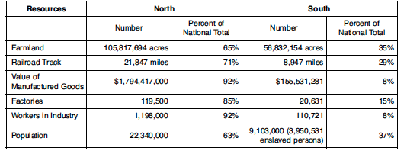

22. Which statement is best supported by the information in the chart?
(1) The South had a greater percentage of workers in industry than did the North in 1861.
(2) The South had more farms than did the North in 1861.
(3) The North had many advantages over the South at the beginning of the Civil War.
(4) The North and South produced equal amounts of manufactured goods prior to the Civil War.

23. Laws that established literacy tests, poll taxes, and grandfather clauses were passed by
Southern states to:
(1) raise money to rebuild the South after the Civil War
(2) improve the education of United States citizens
(3) limit the rights of formerly enslaved persons
(4) support the Radical Republicans

